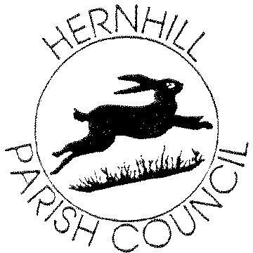
HERNHILL PARISH COUNCIL

All Parish Council meetings will be held at 8:00pm online (unless otherwise notified). Members of the public are welcome to attend meetings. Due to Coronavirus these are being held bi-monthly for the time being with extraordinary planning meetings as and when required.

MEETING SCHEDULE 2021
January 27th March 31st
May 26th
July 28th September 29th
November 24th

COUNCILLORS
Mrs J. Geliot (Chairman) Mr S. Edgington (Vice-Chairman)
Mr P. Couzens Mr C. Page Ms A. Rumble Mr S. Castle Mrs B. Heller

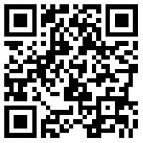
HERNHILLCLERK@GMAIL.COM

WWW.HERNHILLPARISHCOUNCIL.ORG

